**Reading at Bollington Cross CE Primary School**

**Dear families**

Your child has recently moved to the next book band. They have shown great improvement in the decoding of words. We are going to do a big push on the text and understanding what they have read.

**What’s next?**

Both in school and at home our focus will turn towards language comprehension and understanding. The image below identifies how reading comprehension is the sum of many parts:

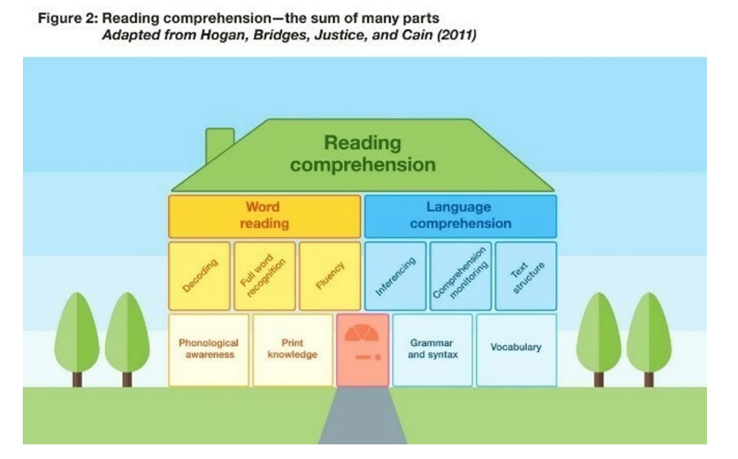

**Reading lessons**

In your child’s reading lessons in school, they will be taught specific strategies to support them with inferencing and self-monitoring their understanding. These include: prediction; questioning; clarifying; summarising; and activating prior knowledge.

**At home**

Children will now be assessed based on their word reading and their language comprehension and will be bringing home appropriate colour banded books for their level.

To support your child at home, please continue to help them to develop a love of reading - use the attached resources to support you to ask questions and continue to develop ‘book talk’ within your home.

In addition to the colour banded books that are brought home, please also continue to enjoy all other reading material with your child: picture books, comics, non-fiction texts, recipes, signs at museums/the zoo … the opportunities for reading are endless.

Thank you for continuing to support your child’s reading journey.

Thanks

L Smith

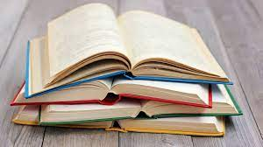Questions to Ask at Home

**Questions to ask before you read**

* Can you look at the pictures and predict what you think will happen in this book?
* What makes you think that?
* What characters do you think might be in our story?
* Do you think there will be a problem in this story? Why or why not?
* Does the topic/story relate to you or your family? How?

**Questions to ask during reading**

* What do you think will happen next?
* What can you tell me about the story so far?
* Can you predict how the story will end?
* Why do you think the character did _______?
* What would you have done if you were the character?
* How did the character feel when ______? How would you have felt if you were the character?
* As I read____________, it made me picture________ in my head. What pictures do you see in your head?
* Can you put what you’ve just read in your own words?

**Questions to ask after reading**

* Can you remember the title? In your opinion, was it a good title for this book? Why or why not?
* Were your predictions about the story correct?
* If there was a problem, did it get solved? How was it solved?
* What happened because of the problem?
* Why do you think the author wrote this book?
* What is the most important point the author is trying to make in his writing?
* What was your favourite part of the story?
* If you could change one thing in the story, what would it be?
* Can you retell the story in order?
* If you were __________, how would you have felt?
* What is the most interesting situation in the story?
* Is there a character in the story like you? How are you alike?
* Why did you like this book?

Questions to Ask at Home

**Explain**

To draw on your child’s knowledge of vocabulary to understand texts:

• Which words describe…?

• Find and copy one word that tells you that……

• What does the word …….. mean in the sentence?

• Find and copy two words that describe how …..

• Look at the paragraph…… which word that means the same as ……

• Draw lines to match the word with their meaning.

• Which word means the same as……..

**Retrieve**

Identify/explain key aspects of fiction & non-fiction texts, such as characters events, titles & information:

* + Find and copy two bits of information about the text.
  + What happens…?
  + What could he/she see/do?
  + Where did (something) happen?
  + How did it happen?
  + What was the character worried/happy/____ about?
  + Why did the character want to …..?
  + Draw lines to match who said what.
  + When/Where did _______happen?

**Inference**

Making inferences from the text:

* + Why did ‘character’ say/do that? (Use ‘because reasoning’ ‘Because …. ‘)
  + Give two things that tell you why the character acted that way.
  + Why/What was the ‘character’ feeling….?
  + Why did (something happen)?
  + When did that happen?
  + How do you know …?
  + How can you tell that (it is late/the …. is …….)?
  + How did ‘character’ feel?
  + The character did something because….
  + Why was the character sad/happy/angry …?
  + The character said “…….” What does this show?
  + What do they mean? (e.g. how is the child wrapped in a warm coat like a parcel)?
  + Which 2 words show _______________
  + How is something like something else?

**Predict**

Predict what might happen on the basis of what has been read so far:

* + What do you think is going to happen:
  + Next
  + At the end of the chapter/story
  + To the character