Homework September 2024

* Spelling~ Your child has brought a yellow book home today. This is the Spelling Homework book and needs to be in **every Tuesday.**

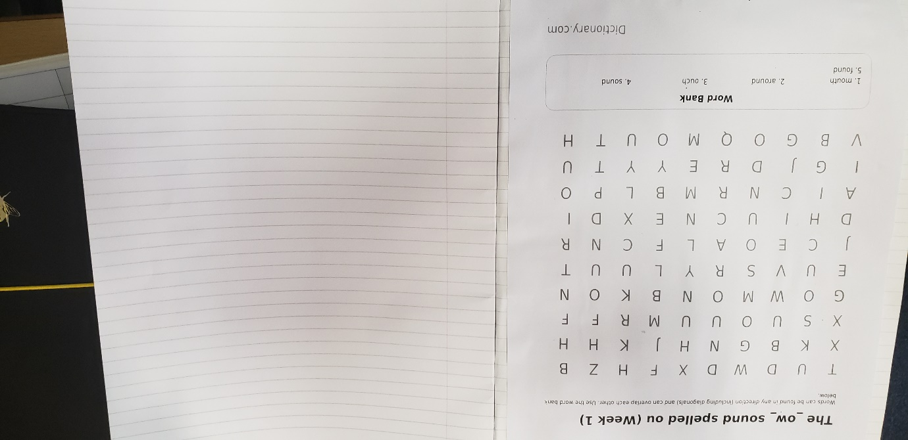In that yellow book there is a word search and the words that you are finding. These are the spelling test words and they will be tested on these words the following Tuesday. (Some children will have a different spelling list)

Spelling words to practice

Page to practice using the spelling words

On the front of the Yellow book is the log in to Ed shed~ this is a different way to practice the spelling words. If I have done it correctly the spelling lists should link to the wordsearch words.

<https://www.edshed.com/en-gb/login>

* Reading~ I would like you to aim to listen to your child read at least 3 times a week. I am hoping to send a book home by the end of the week (sorry for the delay). I will collect the Reading Records in and award dojos for entries.
* Each child will have an English and a Mathematics ’10 Minute Challenge’ book (CGP). These books cover relevant content for the specific year group. Each book contains a set of ‘workouts’ for each term and teachers will set one Mathematics ‘workout’ and one English ‘workout’ per week. I will send these books out as soon as they arrive. Please encourage your child to attempt as much as they can in about 10 minutes. Again, dojos with be given on effort.

If you have any difficulties completing the above please feel free to dojo me and we can discuss alternatives.

Thanks L Smith and S Flynn